INTRODUCTION TO MICROCONTROLLER PROGRAMMING WITH THE BBC micro:bit and MicroPython
The requirements for this tutorial include the following:
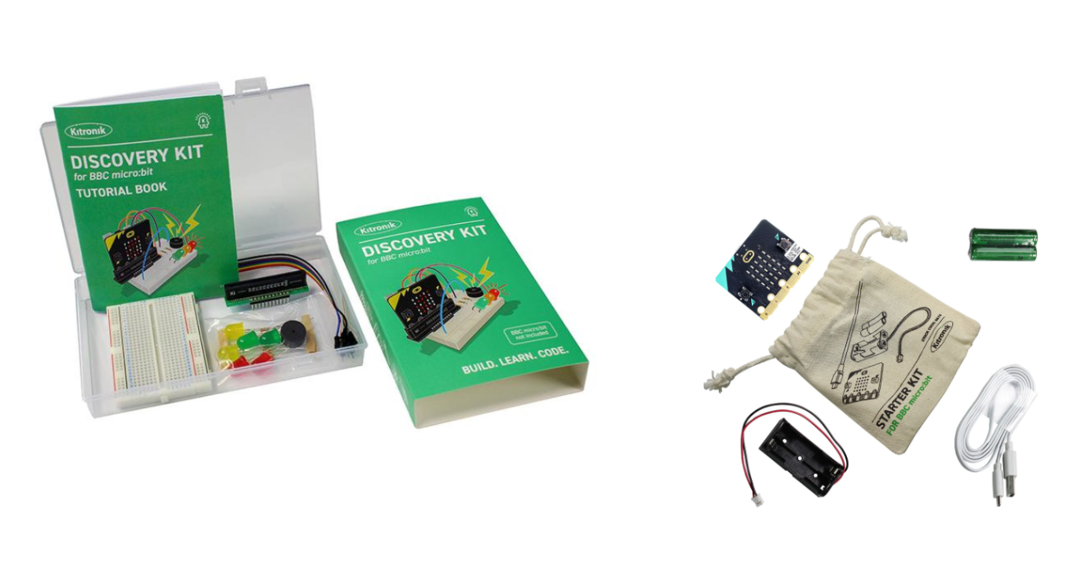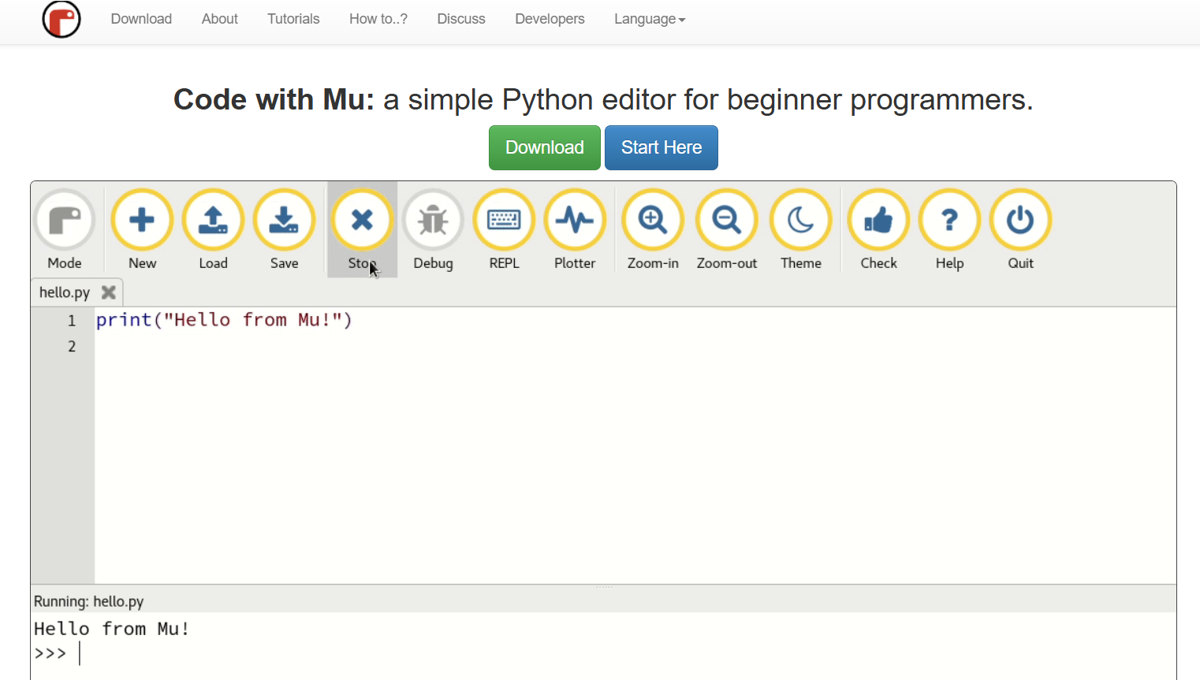
- The BBC micro:bit kit which includes the following: micro:bit controller, a breadboard, kitronik breakout board, LEDs, and more.
- Mu Python Editor from the codewith.mu website installed on your computer.
Install and Open the Mu Editor. We can use Mu for a variety of programming applications.

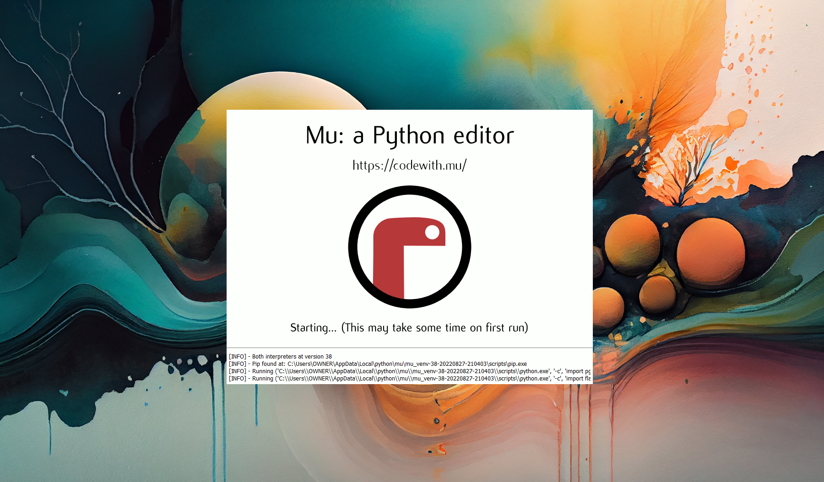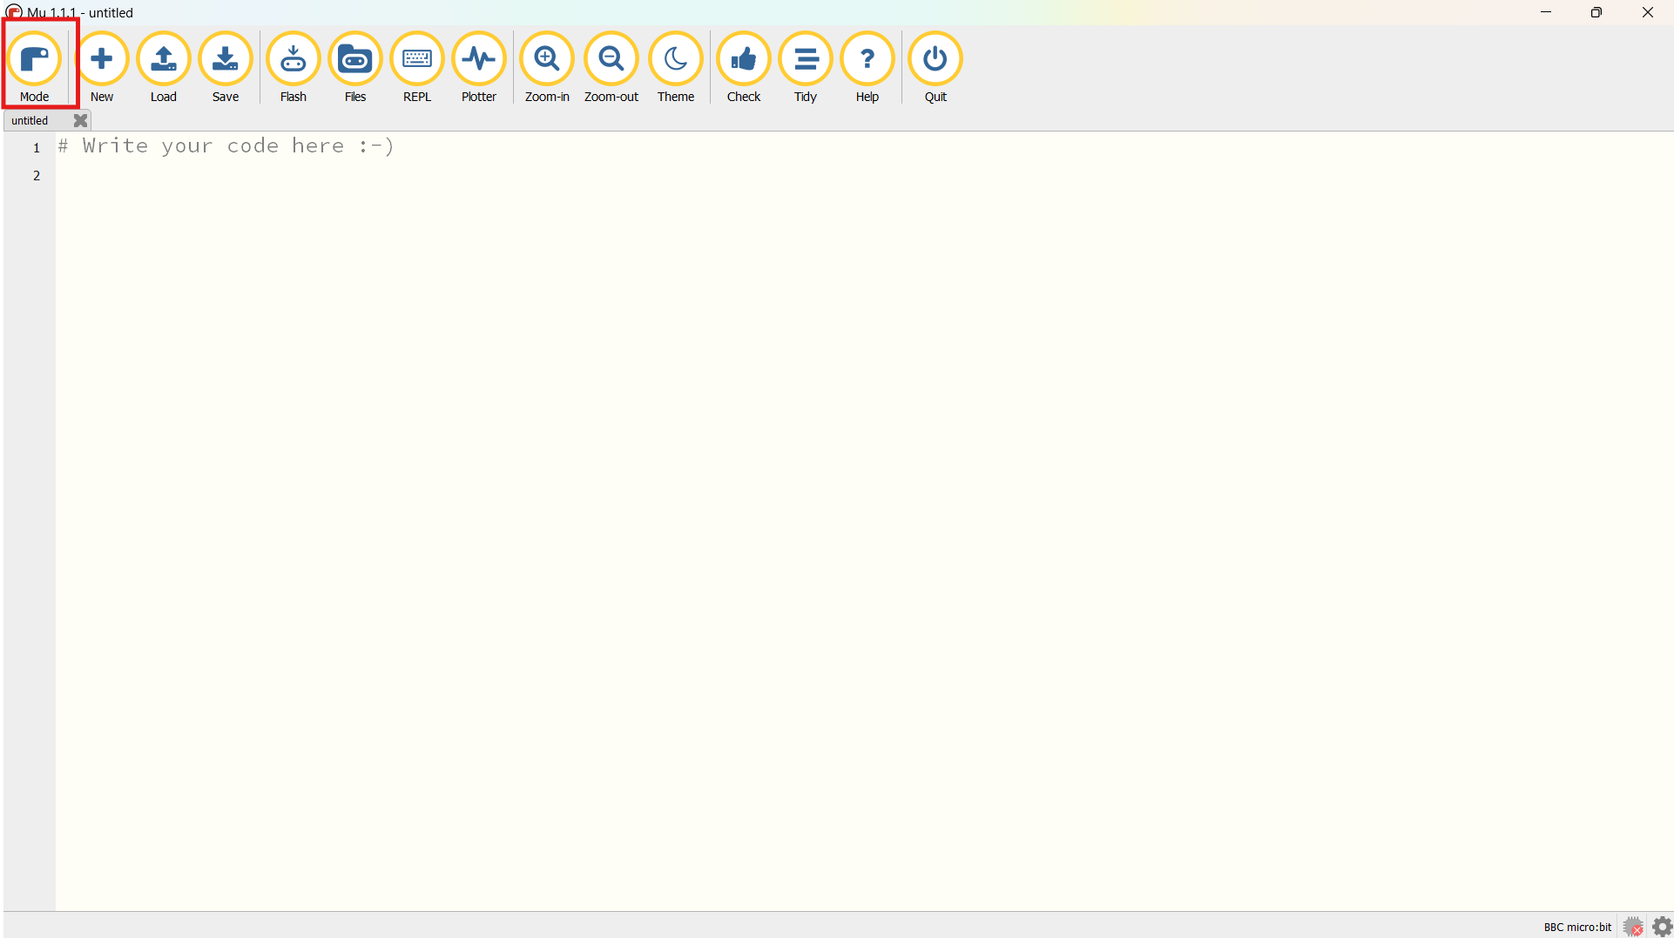

On the top right corner, click on the ‘Mode’ button and select ‘BBC micro:bit’ and click ‘OK’.

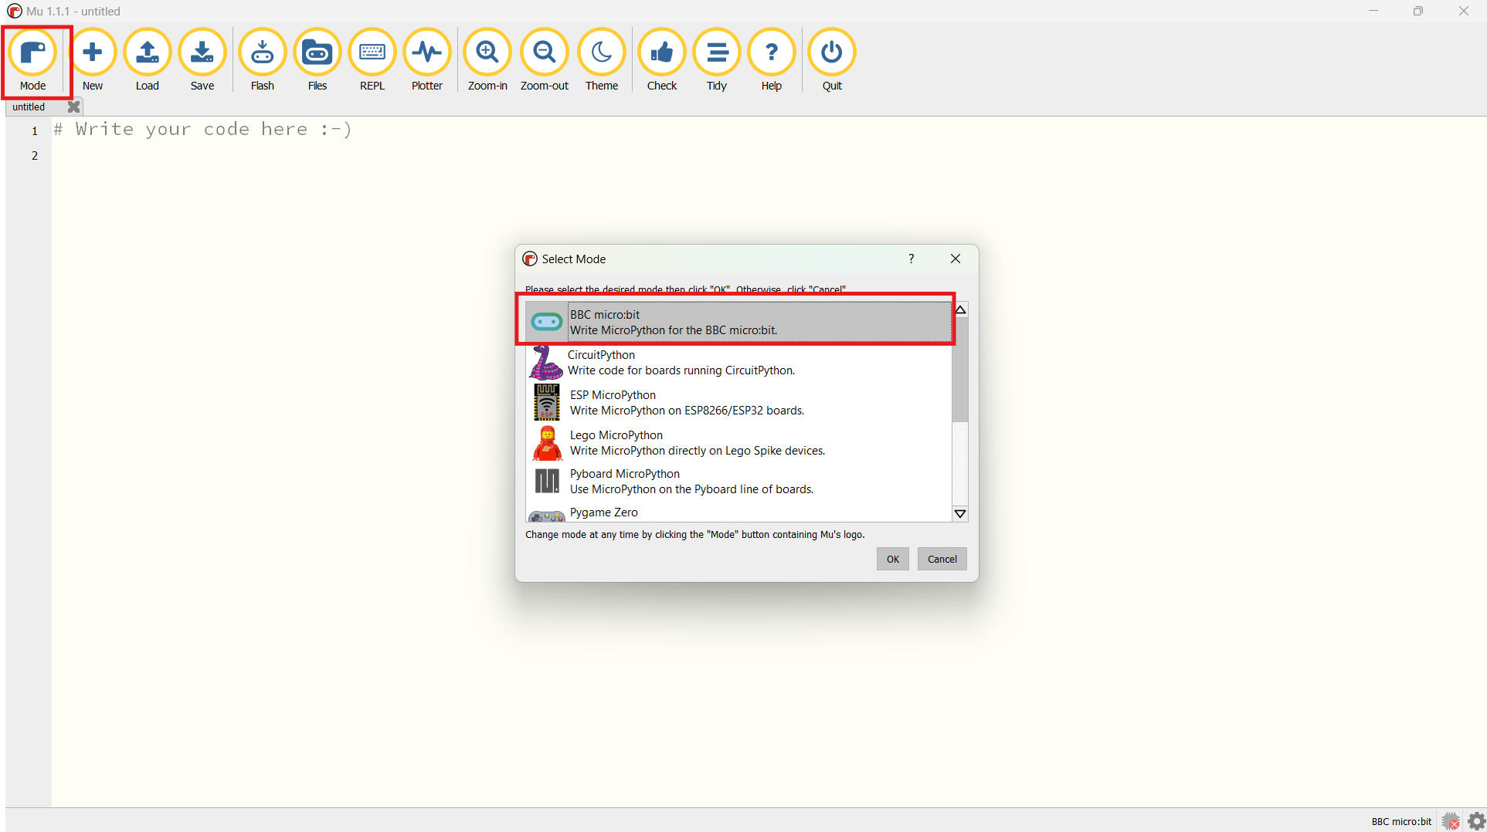
Here is what the BBC micro:bit looks like, with its various components.

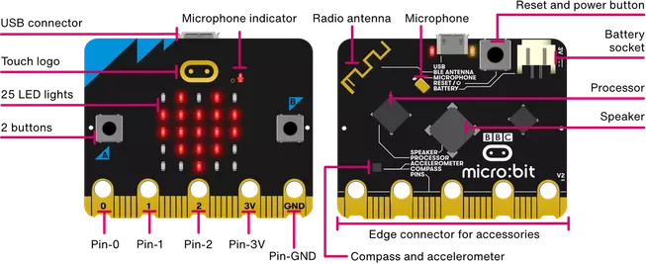
From Overview | micro:bit (microbit.org)

To start using the micro:bit, plug in the USB Cable into the micro:bit’s USB Connector, and then your Computer. With the Mu Editor opened, your BBC micro:bit will be automatically detected and configured. We are ready to start programming in MicroPython on our BBC micro:bit now.

Here is a snippet of code to think about. Write the following in your Mu Editor.

from microbit import *
while True:
display.show(Image.HAPPY)

Click on ‘Save’, and name your file. I saved mine as ‘first_microbit_programme.py’.
Click on ‘Flash’ to load the code onto the micro:bit and observe what happens.

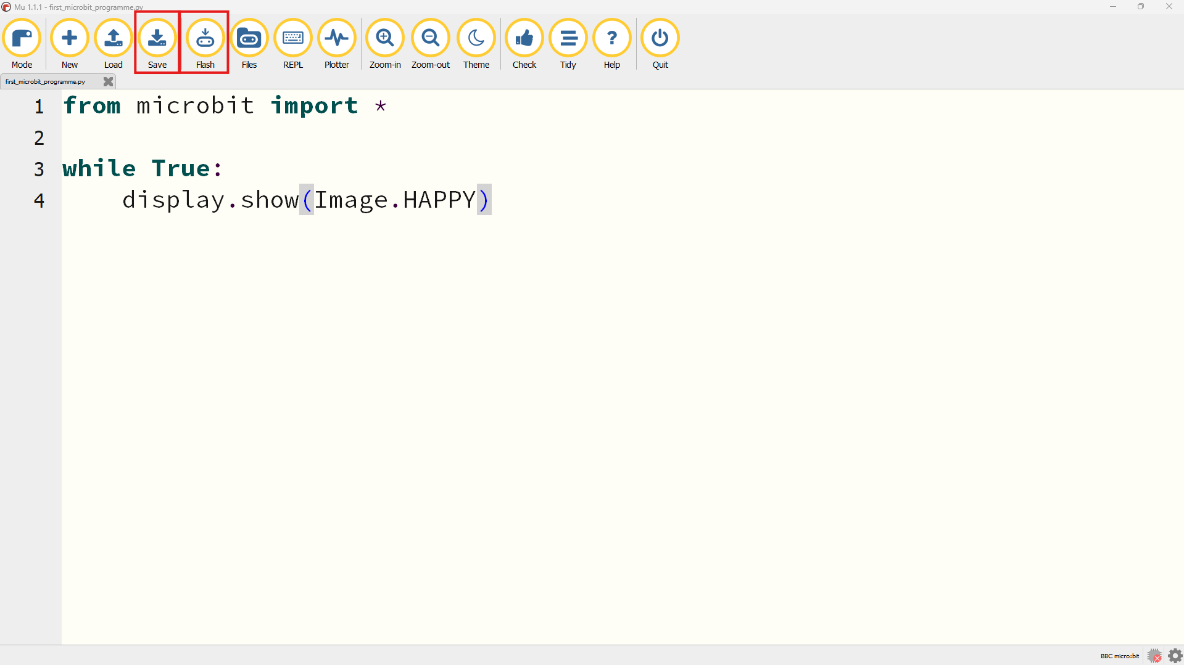
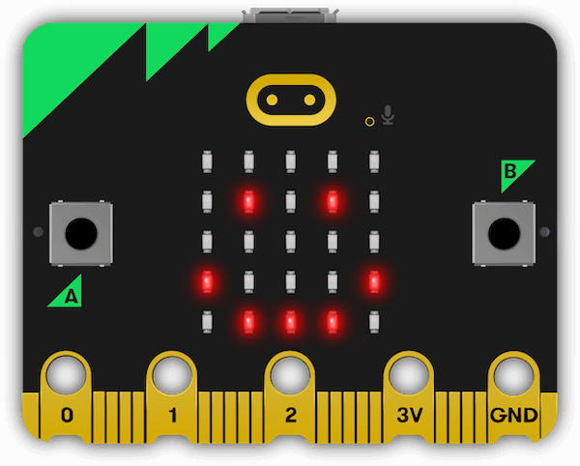
Click on the ‘Reset Button’ on the micro:bit to start running the Flashed programme. Now, we have a Happy mico:bit.

We will use the next section in describing what MicroPython is, parts of a basic MicroPython programme, and how to write a MicroPython programme to perform various functions on the micro:bit.

It is important to realise that, learning to programme on the micro:bit is a transferable skill, and can help us get started with learning to programme for other applications such as; Python Scripting, Web Development, IoT, Data Science, and a lot more.

What is MicroPython?
MicroPython is a version of Python that is designed to be run on microcontroller devices such as the micro:bit. Python is the most popular programming language in the world, empowering several applications you may have heard about, including Google, YouTube, Spotify, and some NASA tools.

Learning MicroPython is easily translatable to using the actual Python programming language, as well as other programming languages (JavaScript, C/C++, Go, Rust, etc) with some amount of learning and practice.
(Source: Introduction — BBC micro:bit MicroPython 2 documentation (microbit-micropython.readthedocs.io))

MicroPython comes with a special module called ‘microbit’, which is what allows us to control the BBC micro:bit with code. In Python, a module is a collection of functions grouped together to perform a specific task or related tasks.
Going back to the example code that was provided above, in the first line of code we have the following:
from microbit import *

This line of code simply means that, from the microbit module that exists in MicroPython, we are importing all the functions available into our programme. These functions are what then enables us to draw Smiley Faces, Print Text, Blink Leds, and do a whole lot more on the micro:bit.

while True:
display.show(Image.HAPPY)

The second line of code says ‘while True:’ This is used in creating an infinite loop that never ends. The block of code written under the ‘while True:’ statement will keep running forever, unless interrupted or the microcontroller is turned off. (In this case, our little smiley face never goes away). This describes how most microcontroller devices work, as they remain in an infinite loop forever. A traffic control system for example. Speaking of traffic control systems, why not make one with the micro:bit?

What Can We Do With micro:bit and MicroPython?
MicroPython comes with several in-built functions for using the micro:bit. The micro:bit comes with some onboard sensors for collecting data from the environment.
Some of the main sensors on the micro:bit include the following:

- Microphone: For recording sounds.
- Speaker: For playing sounds.
- Accelerometer: For measuring x, y, z positions.
- Thermometer: For measuring ambient temperature.
- Light sensor: For detecting light

Main Micro:bit Functions and Modules:
Display: Control the LED matrix for showing images, text, or scrolling messages. (e.g. display.show(Image.HAPPY), display.scroll("Hello!")
from microbit import *
display.scroll('Hello!', wait=False, loop=True)
Image: Create and manipulate images for display. (More examples here)
Image.HEART_SMALL, Image.HAPPY, Image.SMILE, Image.SAD, Image.CONFUSED Image.ANGRY, Image.ASLEEP, Image.SURPRISED, Image.SILLY, Image.FABULOUS, Image.MEH, Image.YES, Image.NO, Image.CLOCK_ALL
Image.PACMAN, Image.TARGET, Image.TSHIRT, Image.ROLLERSKATE, Image.DUCK, Image.HOUSE, Image.TORTOISE, Image.BUTTERFLY, Image.STICKFIGURE, Image.GHOST, Image.SWORD, Image.SKULL, Image.UMBRELLA, Image.SNAKE, Image.SCISSORS
from microbit import *
while True:
display.show(Image.HEART)
sleep(1000)
display.show(Image.HAPPY)
sleep(1000)
- Button: Read the state of the buttons (A and B) on the micro:bit. (e.g. button.a.is_pressed()
from microbit import *
while True:
if button_a.is_pressed():
display.show(Image.HEART)
elif button_b.is_pressed():
display.show(Image.HAPPY)

- Temperature: Read the ambient temperature in degree celsius using the built-in thermometer.
from microbit import *
while True:
display.scroll(temperature())
Let’s take a break here and try our hands on a tiny experiment. Here are the step by step instructions.
- Import the microbit module
- Write the while True: statement
- Set an if condition that when temperature is greater than 32, a SAD image should be displayed.
- Set an else if (elif) condition that when temperature is less than 32, a SMILE image should be displayed.
Good luck.
Radio (two-board communication — Thursday)
Call | What it does
import radio | Radio is on by default once imported.
radio.config(channel=7, group=0) | Set a shared channel so boards can hear each other (must match on both).
radio.send(message) | Send a text message to any board listening on the same channel.
radio.receive() | Returns the next waiting message, or None if there isn't one.
# Board 1
import radio
radio.on()
radio.send("hello")

# Board 2
import radio radio.receive
radio.on()
incoming = ()
if incoming:
display.scroll(incoming)

- Microphone: Record sound using the microphone.
from microbit import *
while True:
display.show(microphone.sound_level())
- Speaker: Play sounds or melodies through the speaker. (Examples below)
Sound.GIGGLE, Sound.HAPPY, Sound.HELLO, Sound.MYSTERIOUS, Sound.SAD, Sound.SLIDE
Sound.SOARING,, Sound.SPRING, Sound.TWINKLE, Sound.YAWN
from microbit import *
while True:
audio.play(Sound.TWINKLE)
display.show(Image.SAD)
sleep(500)
display.show(Image.HAPPY)
audio.play(Sound.GIGGLE)
sleep(500)

- Accelerometer: Measure movement and orientation using the accelerometer. We can get X, Y and Z orientations from the micro:bit and much more. Examples Below.
up, down, left, right, face up, face down, freefall, 3g, 6g, 8g, shake
from microbit import *
while True:
display.show('5')
if accelerometer.was_gesture('shake'):
display.show(Image.HAPPY)
sleep(2000)

Can you write a programme that checks if the micro:bit is falling?

Light Green - Button/Thing on the micro:bit
Dark Green - Talking about MicroPython
Orange - Button/Thing on the Mu Editor
Blue - Talking about the Mu Editor
Red - Talking about the micro:bit

# DIAGNOSTIC EXERCISE - Find and fix the bugs
# There are 4 bugs in this program.
# Goal: press A to count up, press B to reset, see the count on the LEDs.

from microbit import *

def show_scroll(msg):
display.scroll(msg)

count = 0

while True:
if button_a.was_pressed():
count = count + 1
show_scroll(count)
if button_b.was_pressed():
count = 0
show_scroll("reset")
sleep(200)

